# Guardians of the Dafeng - Complete Walkthrough

## Table of Contents

* Main Quests
* Side Quests
* Map References

## Main Quests

### 1. The Missing Scholar

**Location**: Dafeng Academy

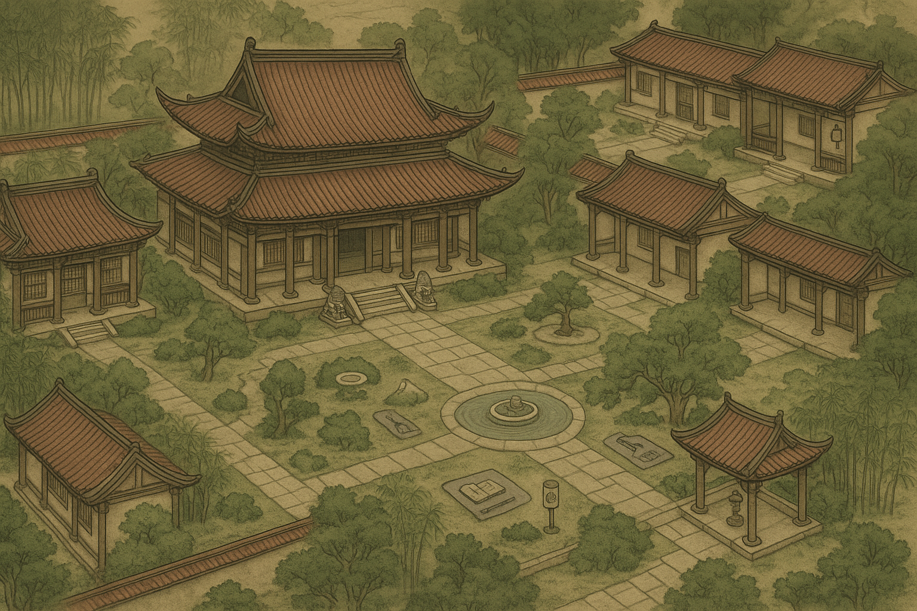  
**Objective**: Investigate the disappearance of Scholar Wei

**Walkthrough**: 1. Start at the Academy courtyard and speak to Master Chen 2. Examine the scholar’s quarters for clues 3. Use Investigation skill on the desk to find the hidden letter 4. Follow the trail to the library archives 5. Discover the secret passage behind the ancient texts 6. Confront the kidnapper in the underground chamber 7. Rescue Scholar Wei and return to Master Chen

**Rewards**: 500 XP, Investigation Skill +2, Ancient Text item

### 2. The Sangbo Lake Mystery

**Location**: Sangbo Lake

  
**Objective**: Solve the mystery of the glowing waters

**Walkthrough**: 1. Meet with the local fisherman at the lake shore 2. Investigate the glowing phenomenon at night (wait until 22:00) 3. Use Cultivation skill to sense the spiritual energy 4. Dive into the lake to find the underwater cave 5. Navigate through the crystal formations 6. Defeat the corrupted water spirit (Level 15 boss) 7. Purify the lake using the Cleansing Ritual

**Rewards**: 750 XP, Water Cultivation Technique, Spiritual Crystal x3

### 3. The Shadow in the Capital

**Location**: Imperial Capital

  
**Objective**: Investigate mysterious assassinations

**Walkthrough**: 1. Report to Captain Li at the Imperial Guard headquarters 2. Examine the crime scenes in the Noble Quarter 3. Interview witnesses using Persuasion skill 4. Follow clues to the abandoned warehouse district 5. Infiltrate the Shadow Sect hideout 6. Battle through multiple assassin encounters 7. Confront the Shadow Master (Level 20 boss) 8. Expose the conspiracy to the Emperor

**Rewards**: 1000 XP, Shadow Step ability, Imperial Recognition

### 4. The Lost Heirloom

**Location**: Various (starts at Imperial Palace)

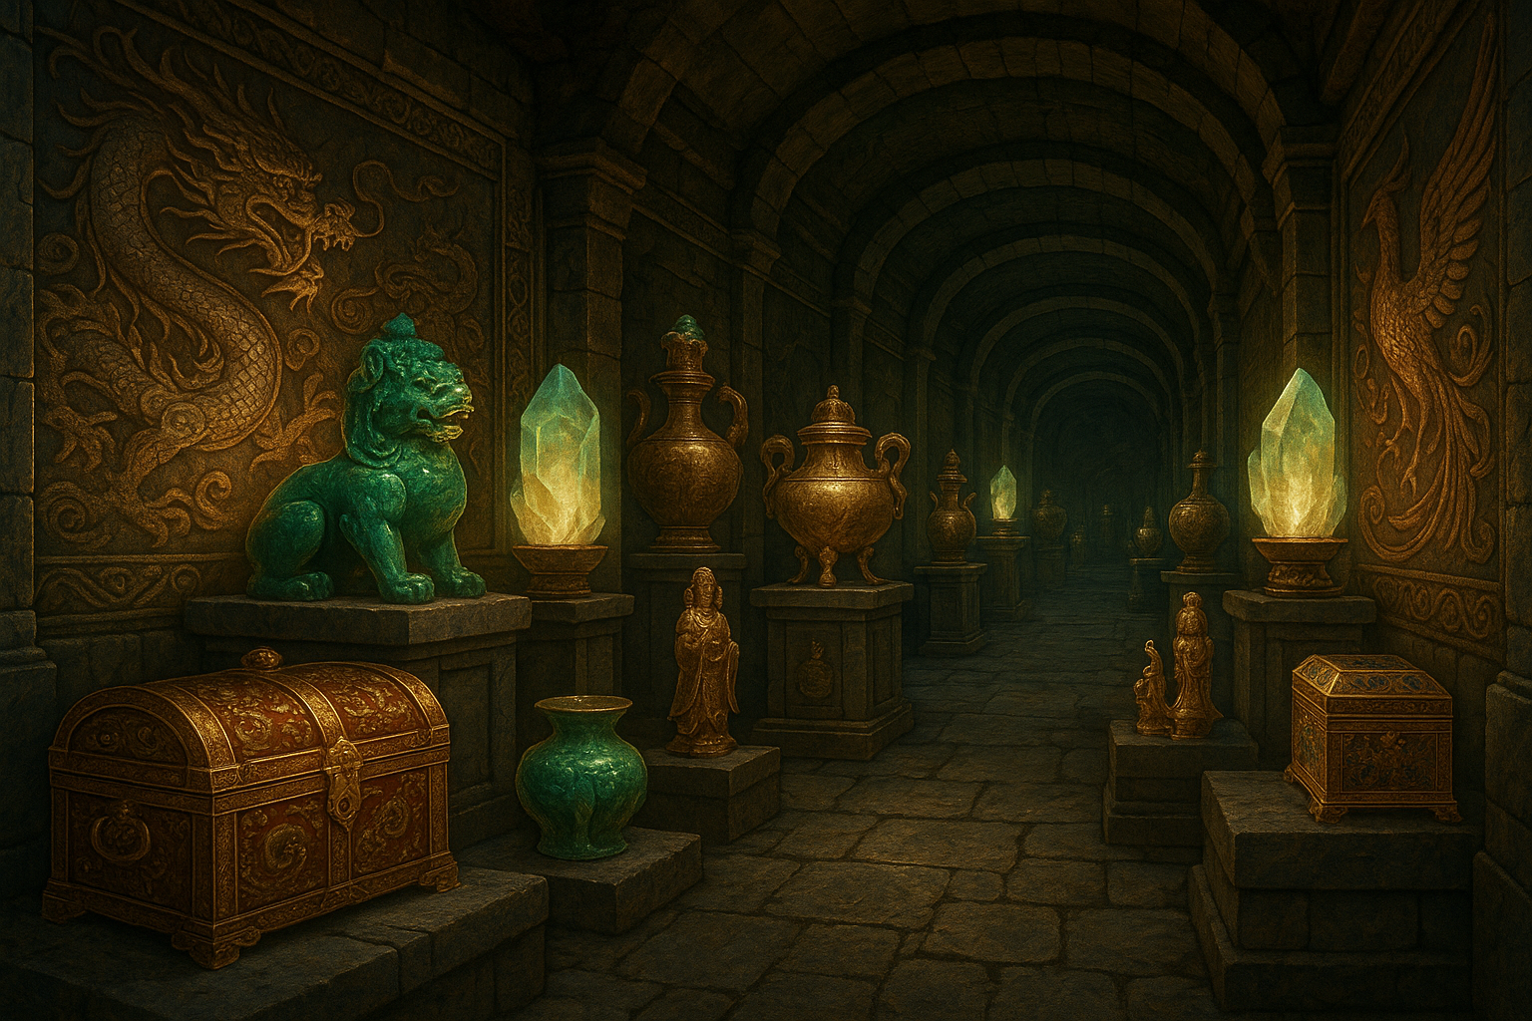  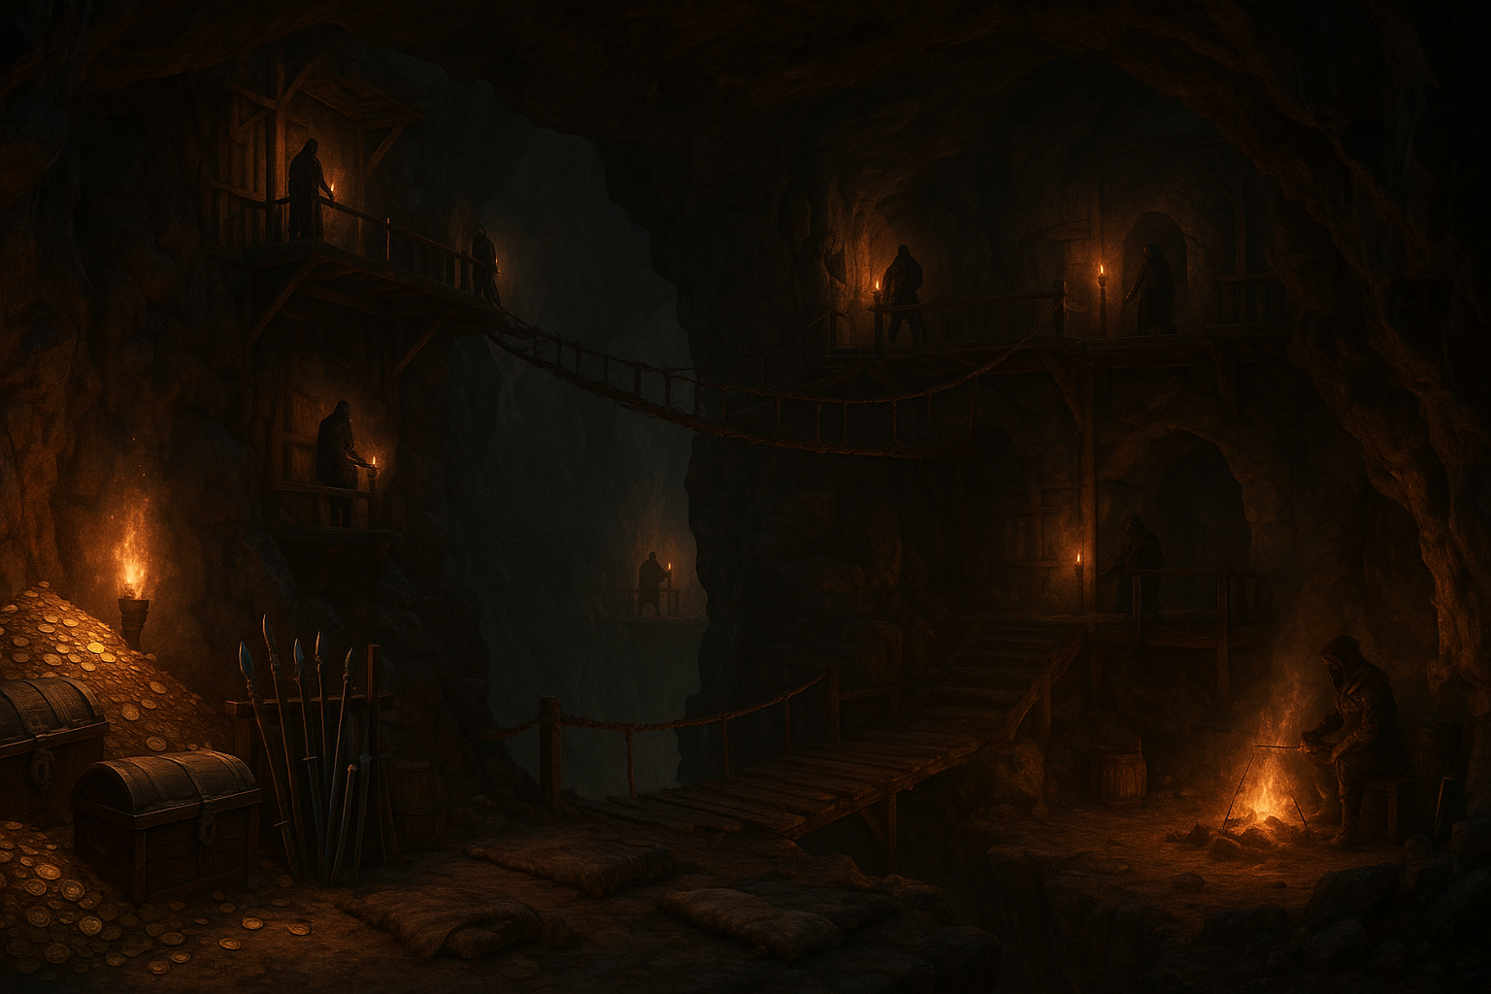  
**Objective**: Recover the stolen Dragon’s Tear artifact

**Walkthrough**: 1. Accept the mission from the Imperial Treasurer 2. Investigate the theft scene in the Imperial Vault 3. Track the thieves to the Mountain Pass 4. Battle bandits and recover partial clues 5. Follow the trail to the Underground Lair 6. Navigate the trap-filled dungeon 7. Defeat the Bandit King (Level 25 boss) 8. Recover the Dragon’s Tear and return to the palace

**Rewards**: 1200 XP, Dragon’s Tear artifact, 5000 gold

### 5. The Celestial Tournament

**Location**: Celestial Arena

  
**Objective**: Compete in the martial arts tournament

**Walkthrough**: 1. Register at the tournament grounds 2. Complete preliminary matches (3 battles) 3. Advance through quarter-finals (stronger opponents) 4. Win semi-final match against rival cultivator 5. Discover the demon infiltration plot 6. Battle the disguised demon in the final match 7. Expose the threat to the Celestial Emperor 8. Receive recognition as tournament champion

**Rewards**: 1500 XP, Celestial Technique, Champion’s Belt

## Side Quests

### 1. The Haunted Temple

**Location**: Ancient Temple

  
**Objective**: Cleanse the temple of evil spirits

**Walkthrough**: 1. Speak with the village elder about the haunting 2. Gather blessed salt from the monastery 3. Enter the temple at midnight 4. Perform exorcism rituals at three altar points 5. Defeat the vengeful spirit (Level 12 boss)

**Rewards**: 400 XP, Exorcism Scroll, Holy Amulet

### 2. The Lost Caravan

**Location**: Mountain Pass

  
**Objective**: Find the missing merchant caravan

**Walkthrough**: 1. Accept quest from Merchant Guild 2. Follow caravan tracks through mountain paths 3. Discover bandit ambush site 4. Rescue surviving merchants from cave prison 5. Defeat bandit leader (Level 10 boss)

**Rewards**: 350 XP, 1000 gold, Merchant’s Favor

### 3. The Missing Child

**Location**: Village outskirts

  
**Objective**: Rescue a child lost in the enchanted forest

**Walkthrough**: 1. Speak with the worried parents 2. Track footprints into the forest 3. Navigate through magical illusions 4. Find the child trapped by forest sprites 5. Negotiate or battle the sprite queen

**Rewards**: 300 XP, Forest Navigation skill, Sprite Blessing

### 4. The Cursed Merchant

**Location**: Market District  
**Objective**: Break a merchant’s curse

**Walkthrough**: 1. Investigate the merchant’s strange condition 2. Research curse origins in ancient texts 3. Gather rare ingredients for counter-curse 4. Perform ritual to break the curse 5. Confront the jealous rival who cast it

**Rewards**: 450 XP, Curse Resistance, Rare Herbs

### 5. The Master’s Test

**Location**: Dafeng Academy

  
**Objective**: Complete advanced cultivation trials

**Walkthrough**: 1. Speak with Grand Master about advancement 2. Complete meditation trial (mini-game) 3. Pass combat proficiency test 4. Demonstrate mastery of chosen element 5. Receive advanced cultivation techniques

**Rewards**: 600 XP, Advanced Technique, Master’s Recognition

### 6. The Alchemist’s Request

**Location**: Crystal Caves

  
**Objective**: Gather rare crystals for alchemical research

**Walkthrough**: 1. Accept commission from the court alchemist 2. Navigate the dangerous crystal cave system 3. Avoid or defeat crystal guardians 4. Harvest three types of rare crystals 5. Return materials for reward

**Rewards**: 400 XP, Alchemical Knowledge, Crystal Essence

### 7. The Goblin Infestation

**Location**: Village farmlands  
**Objective**: Clear goblins from crop fields

**Walkthrough**: 1. Speak with farmers about crop damage 2. Track goblin movements to their lair 3. Battle through goblin warriors 4. Defeat the goblin chieftain 5. Destroy their breeding grounds

**Rewards**: 350 XP, 800 gold, Farmer’s Gratitude

### 8. The Stolen Artifact

**Location**: Museum  
**Objective**: Recover stolen historical artifacts

**Walkthrough**: 1. Investigate the museum break-in 2. Follow clues through the city 3. Infiltrate the thieves’ hideout 4. Battle guards and recover artifacts 5. Return items to grateful curator

**Rewards**: 500 XP, Historical Knowledge, Museum Access

### 9. The Phantom Ship

**Location**: Harbor district  
**Objective**: Investigate ghostly ship sightings

**Walkthrough**: 1. Interview harbor witnesses 2. Wait for phantom ship appearance at midnight 3. Board the spectral vessel 4. Solve the mystery of the cursed crew 5. Help spirits find peace

**Rewards**: 550 XP, Spirit Communication, Phantom Compass

### 10. The Poisoned Well

**Location**: Village center  
**Objective**: Discover source of water contamination

**Walkthrough**: 1. Investigate villagers’ illness symptoms 2. Test water samples using alchemy 3. Trace contamination to underground source 4. Battle corrupted creatures in sewers 5. Purify the water source

**Rewards**: 400 XP, Purification Skill, Village Blessing

### 11. The Forbidden Tome

**Location**: Ancient Library  
**Objective**: Safely retrieve dangerous magical book

**Walkthrough**: 1. Accept quest from worried librarian 2. Navigate library’s magical defenses 3. Solve ancient puzzles to reach restricted section 4. Battle animated book guardians 5. Safely contain the forbidden knowledge

**Rewards**: 650 XP, Magical Resistance, Ancient Wisdom

### 12. The Treasure Map

**Location**: Various locations  
**Objective**: Follow clues to hidden treasure

**Walkthrough**: 1. Purchase mysterious map from merchant 2. Decipher ancient symbols and riddles 3. Visit three marked locations for clues 4. Navigate to final treasure location 5. Defeat guardian and claim treasure

**Rewards**: 700 XP, 3000 gold, Rare Equipment

**Total Quest Content**: 5 Main Quests + 12 Side Quests = 17 Complete Adventures **Estimated Playtime**: 15-20 hours for full completion **Difficulty Range**: Levels 1-30 progression system